**Brief Report:**

Xiangyue Jiao, Wendi Xie, Modric Yue, Tianqiao Zhang

**1. Outline**

We choose topic 5, refraction/dispersion simulator tool. This topic asks us to create a refraction and dispersion simulator tool which users can choose different optical elements/interfaces, different types of glass, different incident light source, and different incident angles. With the change of each input, the incident rays and outcoming rays on the figure will change correspondingly as well. The critical angle is computed. There is an error alert if the input angle exceeds the critical angle. One of the most significant functions of our GUI is enabling that the rays will change accordingly with the change of the inputs.

**2. User guide**

This is a refraction/dispersion simulator.

You can choose different optical elements/interfaces. Options include Air/Glass surface, Glass/Air surface, Plane parallel plate, 60-degree prism, and simple positive lens. The elements on the figure will automatically change when you change the elements by drop-down menu.

Same for optical glass, you can choose the glass you want from the drop-down menu. The refractive index of the glass will change accordingly.

Same for incident light sources, you can pick any source you like from the drop-down menu and the figure will show the rays corresponding to the source you choose.

Same for incident angles. Here you have two different ways to input the incident angle. You can either directly enter the incident angle you want in the “starting ray angle” box or drag the slider handle. The value of the angle will be shown in angle box when you drag the handle.

The critical angle box shows the critical angle according to your inputs. Any incident angle that is larger than the critical angle will trigger the error alert of the simulator. Please enter the angle smaller or equal to the critical angle.

If you have any question, feel free to contact the designers.

**3. Example guide**

Example 1:

Inputs:

|  |  |
| --- | --- |
| Interface type | Air/Glass Surface |
| Glass | N-BK7 |
| Incident ray angle | 30 degrees |
| Light Source | Red chromatic light |

Output:

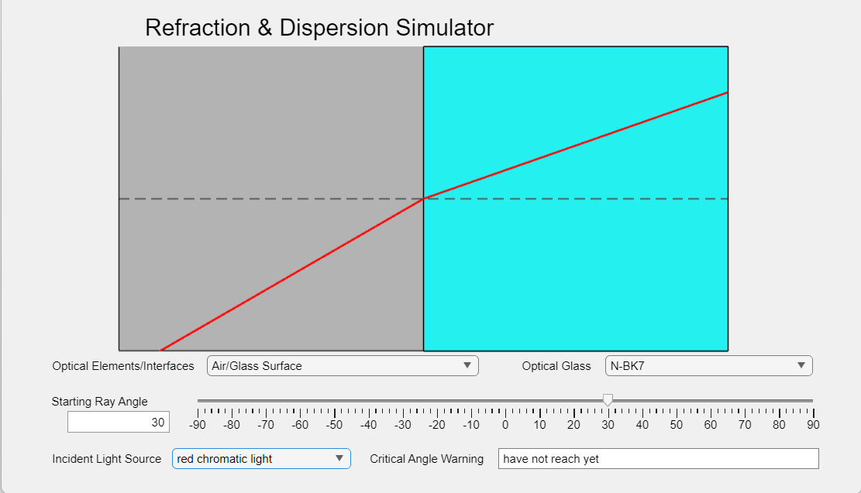

This example demonstrates the fundamental principle of refraction at an air/glass interface using N-BK7, a common optical material. With a 30-degree incident ray and red chromatic light, the simulation clearly visualizes the ray bending towards the normal due to Snell's law. The color-coded interface and real-time feedback, such as the critical angle warning, enhance user understanding of basic optical phenomena. The choice of red light highlights wavelength-dependent refractive indices, making it an excellent educational tool for exploring dispersion and refraction in practical applications like lens and prism design. The clean graphical output ensures accessibility for learners of all levels.

Example 2:

Inputs:

|  |  |
| --- | --- |
| Interface type | Glass/Air Surface |
| Glass | Calcium Fluoride (CaF2) |
| Incident ray angle | 60 degrees |
| Light Source | Yellow chromatic light |

Output:

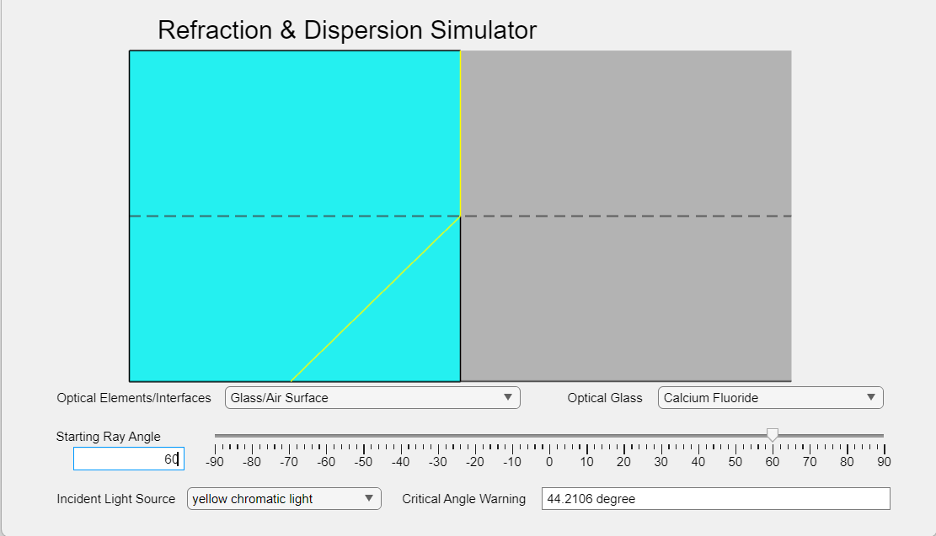

Here we choose Calcium Fluoride (CaF2_22​) as the glass material and set the interface type to Glass/Air Surface, with an incident ray angle of 60 degrees and yellow chromatic light as the source. The simulation output shows the yellow ray being internally reflected, as the incident angle exceeds the critical angle of 44.21 degrees for the CaF2_22​-air interface. This example is interesting because it visualizes total internal reflection, an essential concept in optics, and demonstrates the transition between refraction and reflection dictated by Snell's law. The GUI enhances learning by dynamically updating the critical angle warning and maintaining the refracted ray’s position at the boundary, emphasizing the light’s inability to exit the higher refractive index medium. Such simulations are invaluable for understanding applications like fiber optics and waveguides, where total internal reflection is exploited for efficient light transmission.

Example 3:

Inputs:

|  |  |
| --- | --- |
| Interface type | 60-Degree Prism |
| Glass | N-F2 |
| Incident ray angle | 40 degrees |
| Light Source | white light |

Output:

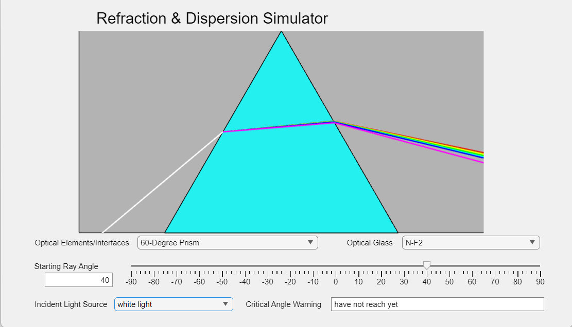

In this example, we use a dispersive equilateral prism made of N-F2_22​ glass and direct white light toward it at an incident angle of 40 degrees. The output demonstrates the dispersion of white light into its constituent colors: red, orange, yellow, green, cyan, blue, and magenta. This result is fascinating because it visualizes the wavelength-dependent refraction caused by the prism's material dispersion properties. Each wavelength experiences a different refractive index within the prism, causing them to refract at varying angles. This example effectively illustrates how prisms are used in practical applications like spectroscopy, where light is separated into its spectral components. The GUI enhances comprehension by clearly distinguishing the refracted colors and providing a vivid, intuitive depiction of dispersion in a controlled environment.

Example 4:

Inputs:

|  |  |
| --- | --- |
| Interface type | 60-Degree Prism |
| Glass | ZnSe |
| Incident ray angle | 40 degrees |
| Light Source | white light |

Output:

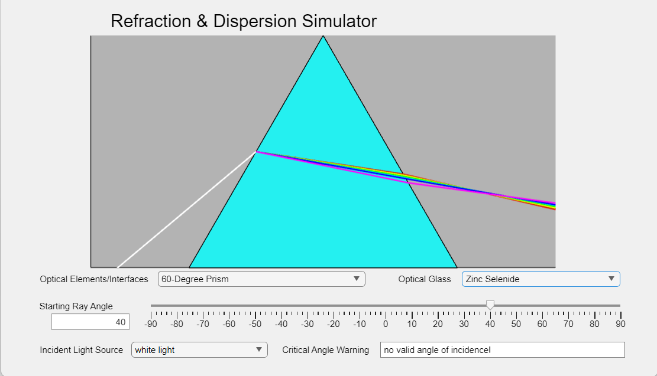

In this example, the material is switched to Zinc Selenide (ZnSe), showing how its higher refractive index compared to N-F2_22​ causes stronger light bending within the prism. Inside the prism, the light diverges, but it converges upon exiting into the air due to the material's refractive properties. This demonstrates how different materials influence dispersion and angular deviation, with ZnSe being ideal for applications like infrared optics. The GUI effectively visualizes these changes, making the material-dependent behavior of light refraction clear and intuitive.

Example 5:

Inputs:

|  |  |
| --- | --- |
| Interface type | Simple Positive Lens |
| Glass | Barium Fluoride |
| Incident ray angle | 45.49721654161871 degrees |
| Light Source | white light |

Output:

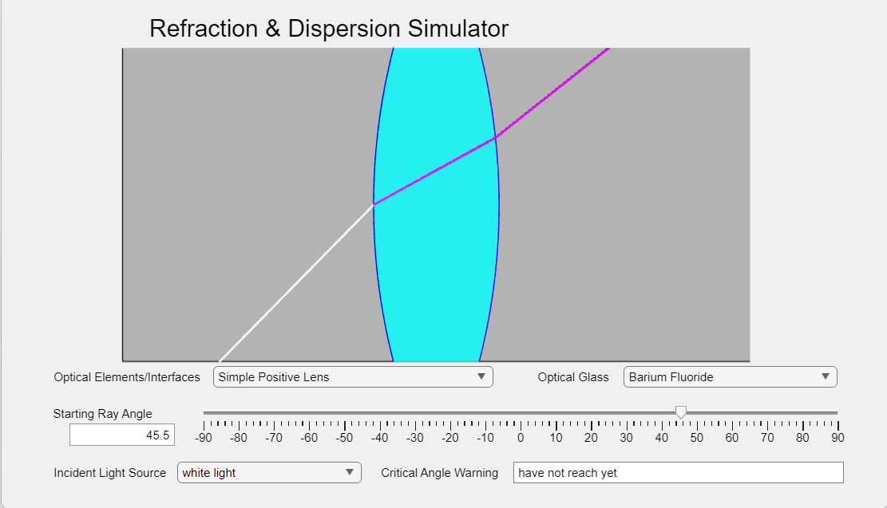

In this example, white light is directed at a simple positive lens made of Barium Fluoride at an angle of 49.97 degrees. The output shows minimal dispersion compared to the previous example with Zinc Selenide. This is due to Barium Fluoride’s higher Abbe number (v=81.78v = 81.78v=81.78) compared to Zinc Selenide (v=8.07v = 8.07v=8.07), as a larger Abbe number indicates lower chromatic dispersion. This example highlights the role of material properties, such as the Abbe number, in controlling dispersion, making it ideal for applications requiring minimal color separation, like high-quality imaging systems.